Test Project
Web Technologies
Module AB

,.
,.

Introduction
In today's world of diverse and vibrant front-end games, we aim to develop a fun and engaging casual game called Castle Guard, which will appeal to a wide range of game enthusiasts. This game blends tower-defense and roguelike elements, where players build structures on map cells to defend the central castle against monster attacks.
We have provided media files that you will need to use appropriately to complete the game.
This project is divided into two parts:
- Phase one (morning): Complete the design of style guide and Home Interface, Gaming Interface, and Rank Interface.
- Phase two (afternoon): Based on the style designed in Phase one, implement the required game interaction features.

Description of project and tasks
This game has three interfaces: Home Interface, Gaming Interface, and Rank Interface. When switching between these interfaces, please develop visually appealing animation effects.
Style Guide:
- Logo
- About This Game
- Buttons
  - The button specifications and styles to be followed in the interface.
- Buildings
  - Wood Castle
  - Stone Castle
  - Silver Mine
  - Gold Mine
  - Bow Tower
  - Longbow Tower
- Monster
- There are also other situations where icons are used to replace text
The Home Interface:
This interface contains the following elements:
- Game Logo
- A required name input for players to enter their names
- A “Start Game” button to begin the game
- A “Rank” button to display the rank interface.

Here are descriptions of the features in Phase two:
- The username must be filled in and can only contain numbers and letters, any symbol is illegal.
- After clicking the “Start Game” button, if the username does not meet the requirements, the game will not start, and a message will appear saying "Please check your name.".
The Gaming Interface:
This interface contains the following elements:
- Name
  - Displays the player's entered name on the home interface.
- Score Counter
  - Displays the player's total score.
- Energy Counter
  - Displays the player's current energy.
- Coins Counter
  - Displays the player's current coins.
- Speed Toggle Button
  - Switches the game speed between 1x and 2x.
- Game Status Button
  - Switches the game status between paused and playing.
  - Phase two: In addition to clicking, the button's functionality can also be triggered by pressing the spacebar on the keyboard in Phase two.
- Settings Button
  - Phase one: The Gaming Interface design must include one visible Settings Button as a placeholder. No save-related interaction is required in Phase one.
- Timer
  - Display the current game time, the time format is mm:ss.
- Wave UI:
  - The Wave UI must remain visible in the same position. When the game is paused, its countdown and remaining monster count must stop updating.
  - Phase one: The Gaming Interface design must display the 10-second preparation countdown in the fixed Wave UI position. The Wave UI may be a visual placeholder at this stage; no countdown, wave, or monster-count interaction is required in Phase one.
  - In Phase two, implement one Wave UI element that remains visible in the same fixed position and switches its content according to the game state:
    - display the 10-second preparation countdown
    - the current wave title after the countdown ends
    - the current wave and remaining monster count during a wave
    - the 5-second countdown before the next wave.

- Building Toolbox
  - Tools for placing Stone Castle (upgrade tool), Silver Mine, Gold Mine (upgrade tool), Bow Tower, and Longbow Tower (upgrade tool).
  - Remove tool for existing buildings, except for the Castle.
  - Phase two: Selecting tools by clicking with the mouse in Phase two.
- Game Map
  - The game map has at least 350 cells
  - Player place, remove or upgrade buildings on cells using the Building Tool.
- The required interactive function is completed in the Phase two.

Here are descriptions of the buildings:
- Wood Castle
60 health points, generates 5 energy per second. This building is automatically placed in the center of the game map at the start of the game.
- Stone Castle
120 health points, generates 10 energy per second. Players can upgrade from Wood Castle to this building using the Stone Castle tool, costing 100 energy and 100 coins.
- Silver Mine
30 health points, each mine generates 5 coins per second. Players can place this building on an empty cell using the Silver Mine tool, costing 30 energy.
- Gold Mine
60 health points, each mine generates 10 coins per second. Players can upgrade from Silver Mine to this building using the Gold Mine tool, costing 60 energy and 60 coins.
- Bow Tower
40 health points, with an attack range of 2-cell radius centered around the building. When a monster is within range, it fires an arrow every second, dealing 5 damage to the monster. Players can place this building on an empty cell using the Bow Tower tool, costing 30 coins.
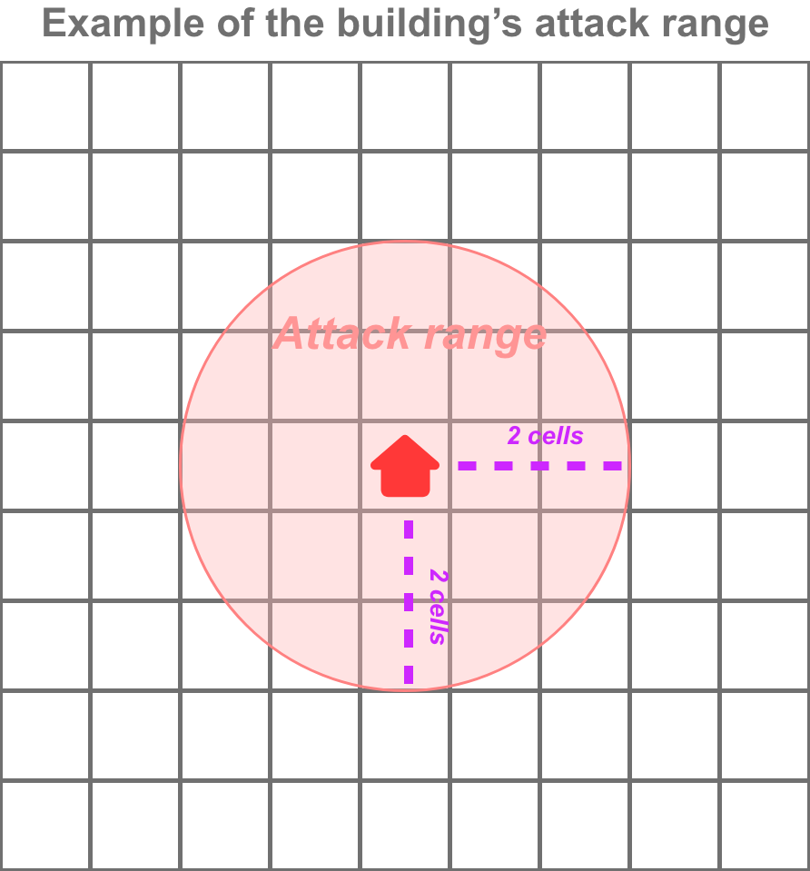
- Longbow Tower
80 health points, with an attack range of 4-cell radius centered around the building. When a monster is within range, it fires an arrow every second, dealing 10 damage to the monster. Players can upgrade from a Bow Tower to this building using the Longbow Tower tool, costing 60 energy and 60 coins.
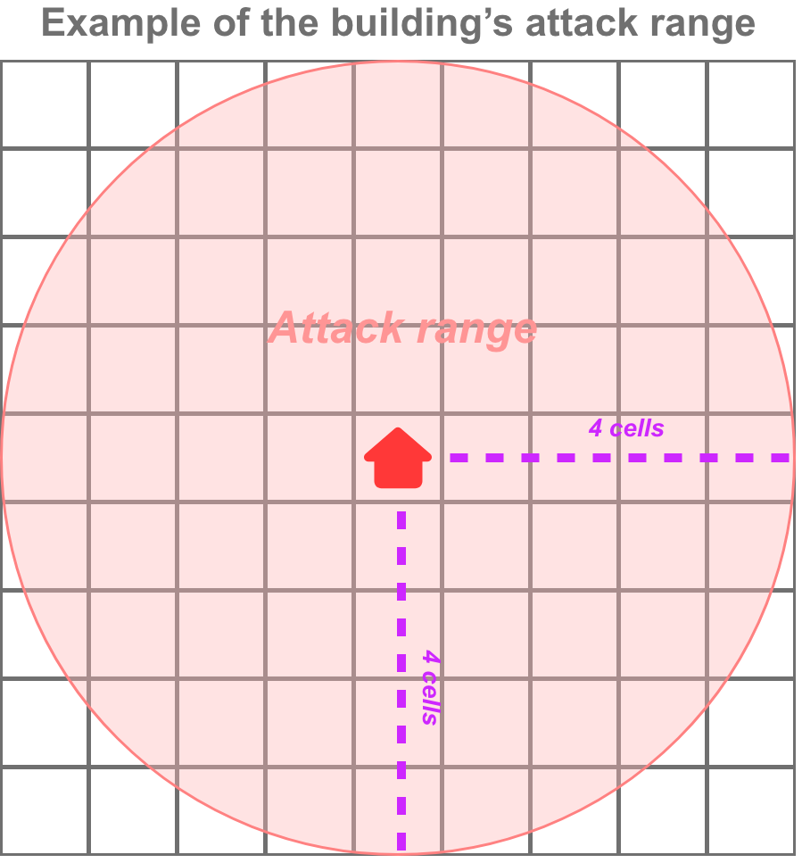
- The required interactive function is completed in the Phase two.

Here is a description of the monster:
Monsters spawn randomly from outside the map, with the goal of destroying the castle located in the center. They have a detection range of 3-cell radius centered around them. If a building is detected within this range, they will move towards that building and attack. Otherwise, they will move towards the castle. If multiple buildings are within the monster's detection range, it will prioritize moving towards the building that is closest to itself.
When the monster moves towards a building, the movement should be direct with an animation, not one cell at a time.
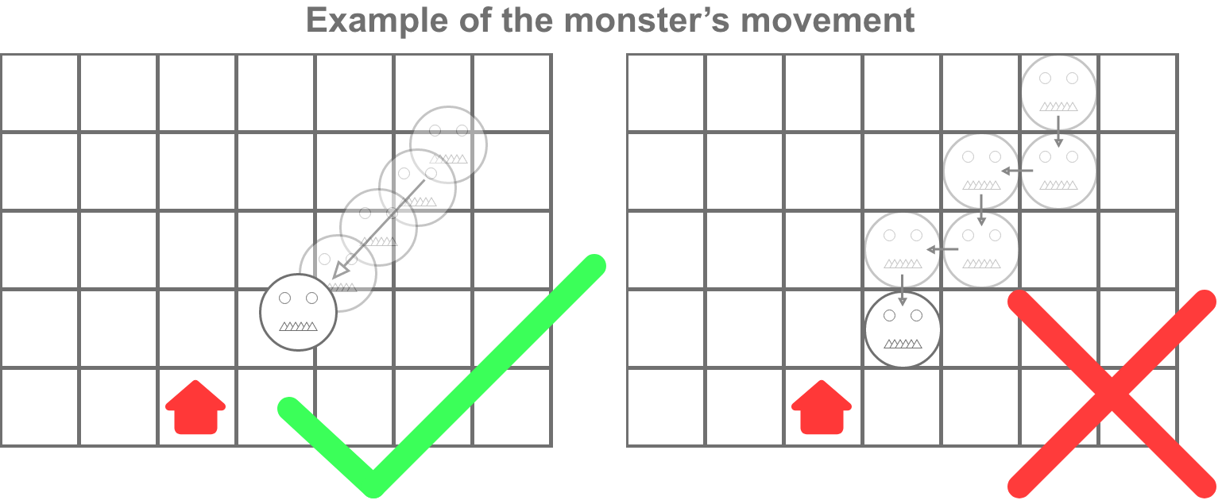
Each normal monster has 30 health points, an attack range of 1-cell radius, and deals 10 damage once per second. Fast monsters first appear in Wave 3. Their movement speed and attack speed are both twice those of normal monsters, but their attack damage remains 10. The number of fast monsters is fixed at 1, 2, 3, 4, 5, and 6 in Waves 3, 4, 5, 6, 7, and 8 respectively. Starting from Wave 9, fast monsters account for 50% of the total number of monsters in each wave. The total number of monsters is 8 in Wave 1 and increases by 2 in each subsequent wave, so the total number of monsters is always even from Wave 9 onward. All monsters have 30 health points through Wave 8. Starting from Wave 9, all monsters gain 5 health points per wave, so Wave 9 monsters have 35 health points, Wave 10 monsters have 40 health points, and so on.
Fast monsters have the same attack range and attack damage as normal monsters.
The required interactive function is completed in Phase two.

Here are descriptions of the features in Phase two:
- After selecting a tool by clicking with the mouse, the player can use the selected tool by left-clicking on the grid cells on the map.
- The player can deselect tool by right-clicking on the game map.
- Only one building can be placed on each cell.
- At the start of the game, there will be a 10-second preparation period. During this time, no monsters will spawn, energy and coins will be generated normally, the game timer will run, players may place, remove, or upgrade buildings, and a visible 10-second countdown must be displayed. After the preparation period, the game enters Wave 1.
- Players can place, remove, or upgrade buildings at any time while the game is not paused, including during the preparation period and the 5-second interval between waves. Building adjustments are disabled while the game is paused.
- When the player has not selected a tool, they can hover the mouse over a building to view its health points and attack range (this action is not affected by the game being paused).
- The game has no maximum wave number. Wave 1 contains 8 monsters, and each subsequent wave contains 2 more monsters than the previous wave. After all monsters in a wave have spawned and been destroyed, a visible 5-second countdown must be displayed before the next wave starts.
- Monsters spawn from outside the map and enter the map, but they are not visible on the screen while they are outside the map.
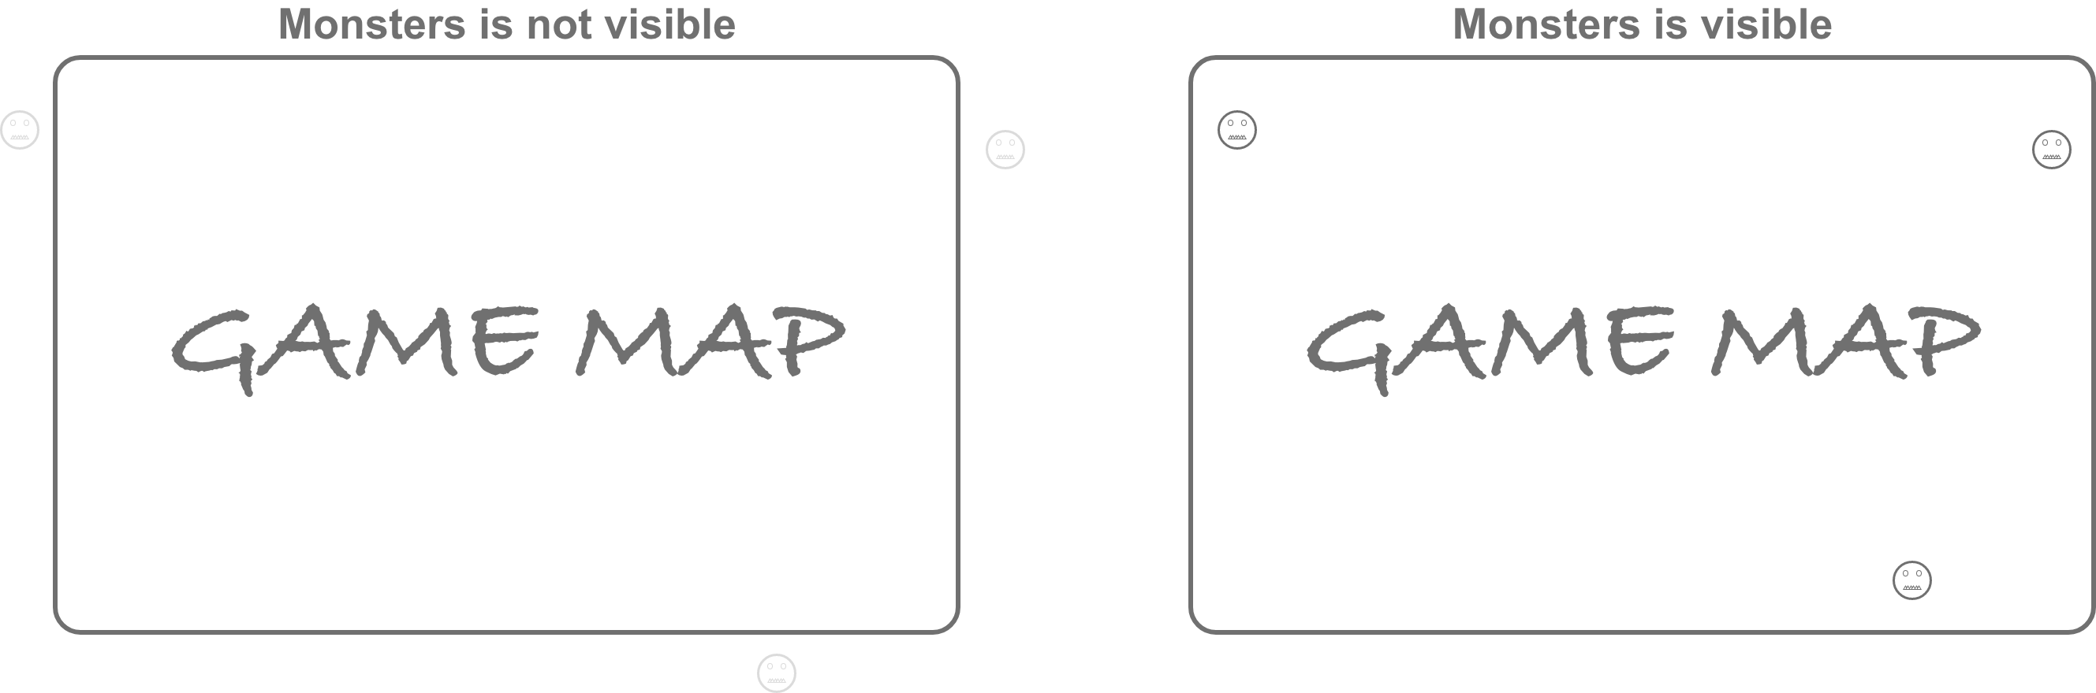
- When the game speed is set to 2x, all time-based game logic, including the game timer, preparation countdown, wave countdown, monster spawn intervals, monster movement, and monster attack intervals, must be accelerated consistently. The total number of monsters, fast-monster ratio, and health-point rules must not change.
- When the game is paused, the game timer, preparation countdown, wave countdown, resource generation, monster spawning, monster movement, and monster attacks must stop. Players cannot place, remove, or upgrade buildings while paused.
- When a building is upgraded, the original building disappears, and its health points are restored.
- Buildings and monsters will be destroyed when their health points reach 0.
- Each monster destroyed adds 1 to the score.
- The Tower's arrows are unable to penetrate multiple enemies.
- When the castle is destroyed, the game ends. Monster spawning, movement, attacks, resource generation, and building adjustments must stop, and the Rank interface is displayed with the final score and time.
- Coins and energy cannot be negative, and a building can only be constructed if the player has at least the required amount of coins and energy. If requirements are not met, the construction must fail, and a message must be displayed to the user to indicate insufficient resources.
- An element can only be detected or attacked when its center enters the range.
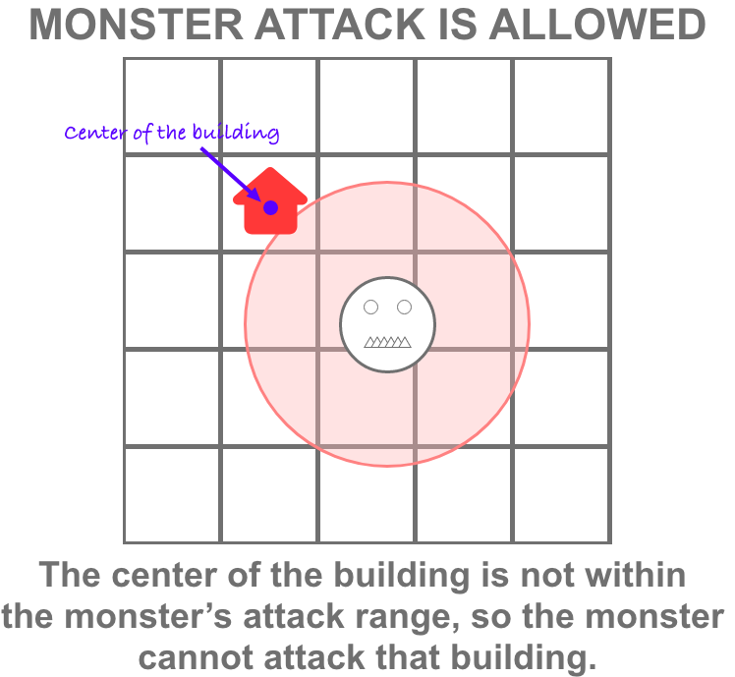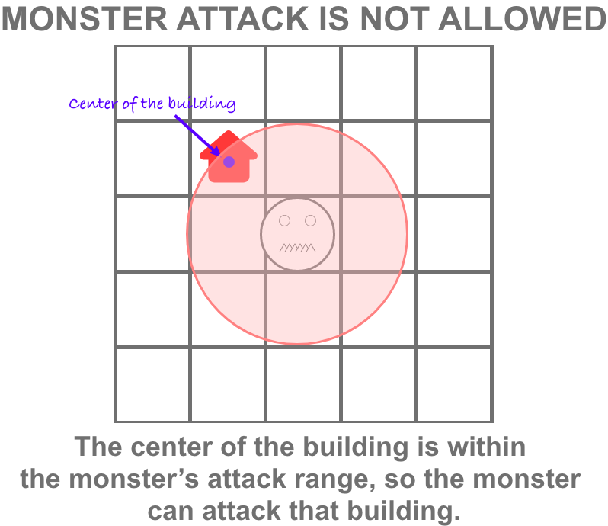
- Clicking the Settings Button must immediately pause the game and open a modal that contains exactly three buttons: Export Save, Import Save, and Exit. Before opening the modal, the system must record whether the game was paused or playing. Exit closes the modal and restores the game to its state immediately before the modal was opened. For example, if the game was paused before opening the modal, it must remain paused after Exit; if it was playing before opening the modal, it must resume playing after Exit.
- Clicking Export Save must create and download a save file containing the current game state. The exported save file must use a structured and readable format.
- A save file must include the player's name, game timer, score, coins, energy, game speed, the game pause or playing state immediately before the Settings modal was opened, current game phase, remaining preparation or next-wave countdown time, current wave, castle state, and every placed building's type, position, and current health points. If a game is saved during a wave, the save file must also include every active monster's type, position, current health points, current target, and remaining spawn or attack timing data, so that importing the save restores the game state accurately.
- Clicking Import Save must open a file selector that allows the player to choose a save file. If the selected save file is valid, the game must restore the saved state accurately. If the file is invalid, incomplete, or contains out-of-range values, the import must be rejected, a visible error message must be displayed, and the current game state must remain unchanged. After a successful import, the Settings modal must close and the game must restore the saved pause or playing state.
The Rank Interface:
This interface contains the following elements:
- Game Logo
- Current Record (Rank, Name, Time, Score)
- Displays all records with pagination
  - Each record includes the rank position, name, time, and score.
  - The rank records are sorted in descending order based on score.
  - If the scores are the same, then sort by time in ascending order. If both score and time are the same, then the rank positions should be the same, and the original position numbers should no longer exist, e.g., 1, 2, 2, 2, 5, 6.
  - The records list must not have any scroll bars and should provide pagination functionality, with each page displaying 10 records.
  - The pagination should have the following functions: the total number of records, the current page number, a button for the previous page, a button for the next page, buttons for the first page, and last page.
- A “Play Again” button to restart the game.
  - Players do not need to re-enter their name after clicking this button.
- A “Home” button to display the home interface.
- The required interactive function is completed in the Phase two.

Instructions to the Competitor
Follow these instructions to submit your work：
- Save the design files in the folder named '{Your Server Address}/XX_Module_A/design/' (XX is your workstation code) in first phase
File names:
- Home Interface: XX_home.png or XX_home.jpg
- Game Interface: XX_gaming.png or XX_gaming.jpg
- Rank Interface: XX_rank.png or XX_rank.jpg
- Style Guide: XX_Styleguide.png or XX_Styleguide.jpg
You can save additional design files for multiple scenarios or interactive explanations. For instance, the file name could be: XX_Styleguide_NN.jpg, where NN represents the scenario number (if applicable).
- Save the layout files in the folder named '{Your Server Address}/XX_Module_A/layout/' (XX is your workstation code) in first phase
File names:
- Home Interface: XX_home.html
- Game Interface: XX_gaming.html
- Rank Interface: XX_rank.html
- Save the working game on the server in the "XX_Module_A" directory for the first phase and the "XX_Module_B" directory for the second phase. Ensure that your main file is named index.html.
- Use meaningful variable names and document your code as much as possible, so that others can easily understand and modify your work in the future.

